**Complete Guide to Building Your Very Own Algae Monitoring Buoy**

**Background**

pH

Optical Density

Turbidity

Temperature

Humidity

Pressure

Water Temperature

**Hardware Configuration**

1. Materials Required
   1. 1 x Arduino or ELEGOO MEGA with USB cable
   2. 1 x SIM 808 General Packet Radio Service/Global System for Mobile/Global Positioning System (GPRS/GSM/GPS) Breakout Board
   3. 1 x GPS antenna
   4. 1 x GSM antenna
   5. 1 x 3.7 Volt, 2200 milliamp-hour lithium-ion battery
   6. 1 x Data logging shield
   7. 1 x CR1220 coin cell battery
   8. 1 x NPN 2N2222 transistor
   9. 1 x ADS1115 Analog to Digital Converter (ADC)
   10. 1 x DP100 epoxy
   11. 1 x 2G/3G capable IoT SIM Card (Things Mobile was used for this example but Hologram cards may also work)
   12. 2 x Barrel connectors
   13. 1 x pH electrode
   14. 1 x JST Connector
   15. 1 x SD Card
   16. 1 x MPU6050 Inertial Measurement Unit (IMU)
   17. Male-male, male-female, female-female jumper wires
   18. Black and red heat-shrink tubing
   19. Electrical tape
   20. Silicone Sealant
   21. 30 AWG wire
   22. White ABS Filament (1.75 mm was used for this example but 3 mm filament should be fine)
2. Tools Required
   1. 1 x Fused Deposition Modeling (FDM) 3D printer with at least 170 mm long, 170 mm wide, 140 mm high print area
   2. 1 x Soldering iron with lead-free solder
   3. 1 x Pair of wire strippers
   4. Glue stick for 3D printer
   5. Voltmeter (optional, for troubleshooting)

**Buoy Shell Fabrication**

First, we will create the buoy structure because it takes the longest amount of time (roughly 30 hours).

1. Set the 3D printer somewhere where it will not move (rubber mats work well).
2. Apply a small layer of glue from the glue stick to the print bed.
3. Set print bed temperature to maximum and nozzle temperature to around 230 F for ABS. A lower bed temperature may cause higher temperature gradients and warping of the part.
4. Upload BuoyTop.stl to your 3D printer’s slicer program and run the slicer. Save the output as BuoyTop.gcode to the SD card provided by your 3D printer.
5. Insert the SD card into the 3D printer and run BuoyTop.gcode.
6. Carefully remove 3D print when complete (can take 20+ hours).
7. Repeat with BuoyBase.stl.
8. Once the BuoyTop 3D print is complete, find the 1 watt, 6 volt solar panel. When tested in this example, the solar panel actually provided 7 volts. Unscrew the small nuts that come with it on the back so there are 4 threads exposed.
9. Find and open the DP100 container and push the epoxy and activator into a small paper plate or cup or other small disposable temporary container. Mix the epoxy and activator with a piece of wood, cardboard, a tongue depressor or a small plastic spoon or knife.
10. Find the 3D printed buoy top. Using the mixing tool you found, apply a moderate amount of DP100 epoxy evenly into the solar panel inset. There should be a thin layer of epoxy/activator that coats most of the bottom of the inset. Push the solar panel electrical connector through the small hole in the inset and press the solar panel back into the DP100 filled inset. Place the buoy top on a newspaper or a few thick paper towels for 24-48 hours to dry.

**Electronics Setup**

While the 3D printer is running, you can work on putting the electronics in the correct configuration

1. **Bend GPRS Shield Pins to Proper Configuration**
   1. Most GPRS shields are designed for Arduino UNO boards, which have a slightly different pin configuration than the Arduino/ELEGOO MEGA. In a nutshell, the Arduino MEGA cannot transmit and receive from pins 7/8, which is what most GPRS shields (including the one we are using) will expect. On the GPRS shield, bend pins 0, 1 (RX, TX), 7, 8 and 9 inwards by ~45 degrees so they miss fitting into the pins on the shield.

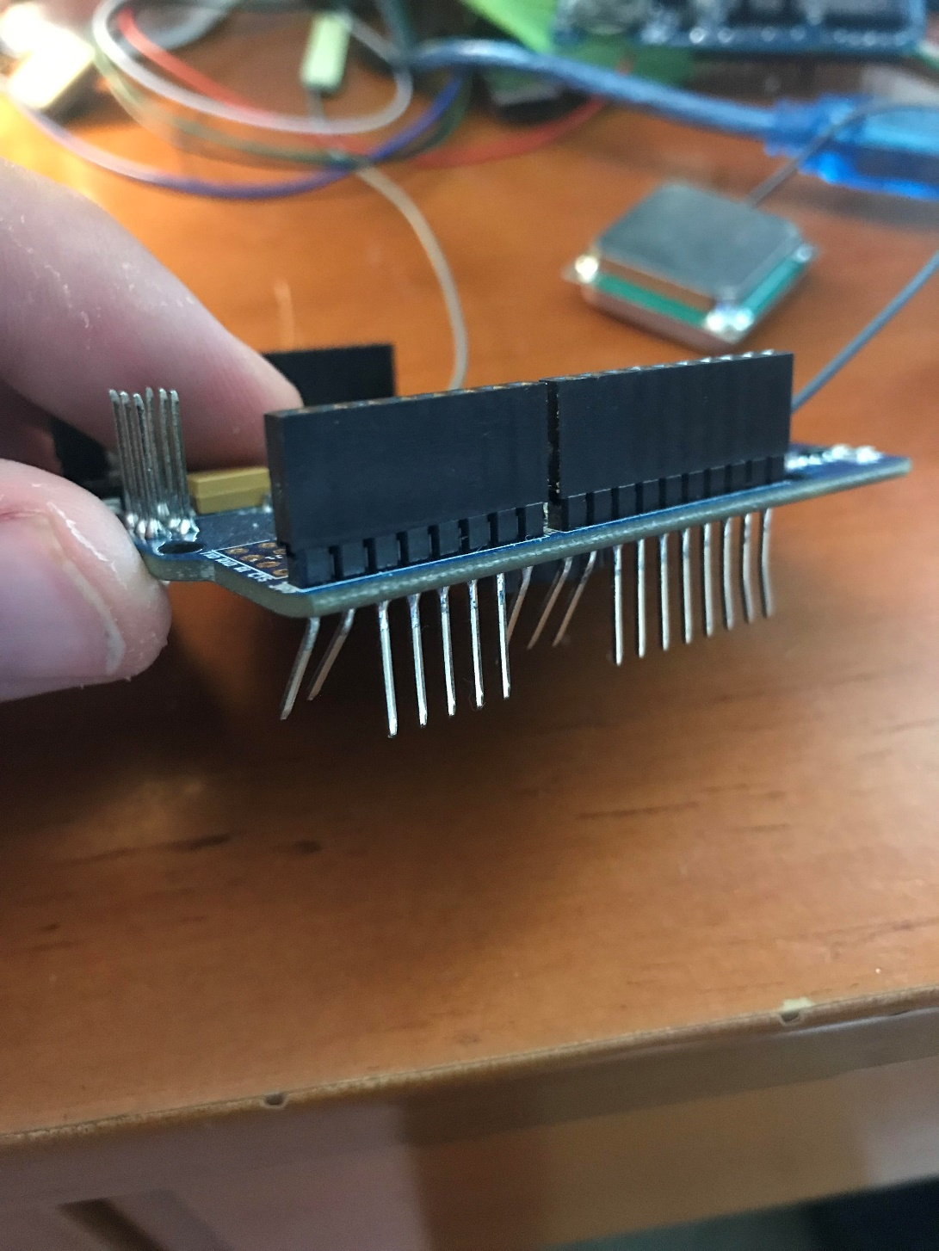

1. **Insert the SIM Card into the Bottom of the GPRS Breakout Board and Close**

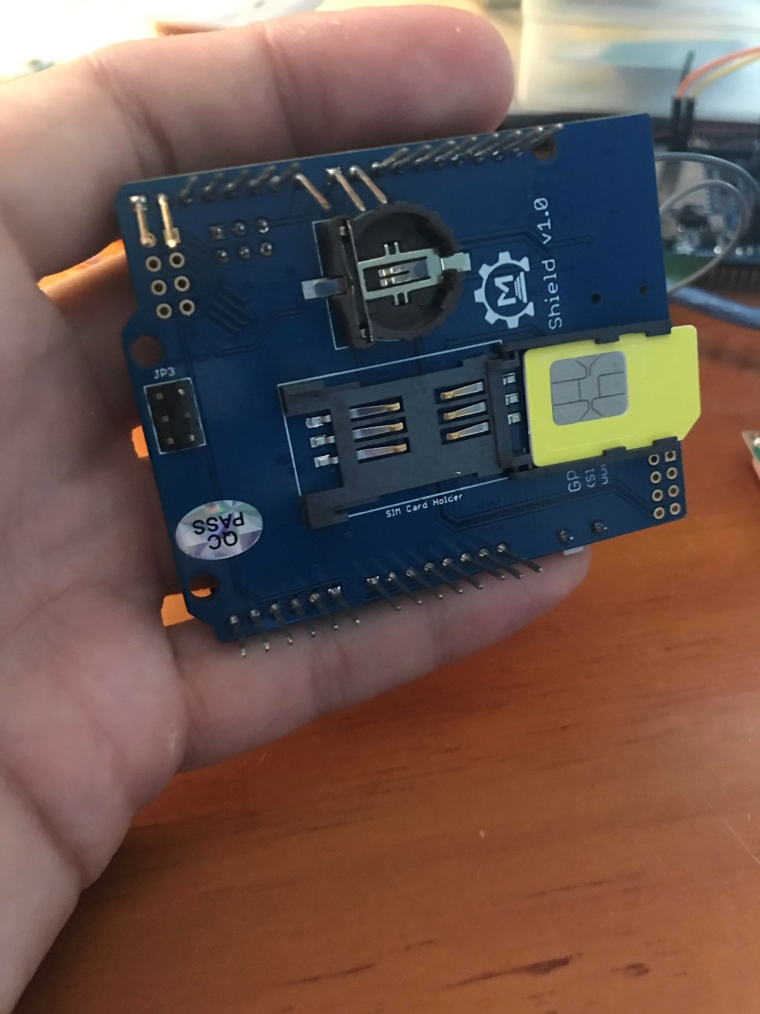

1. **Attach the GPS Antenna and the GSM Antenna as Shown Below**

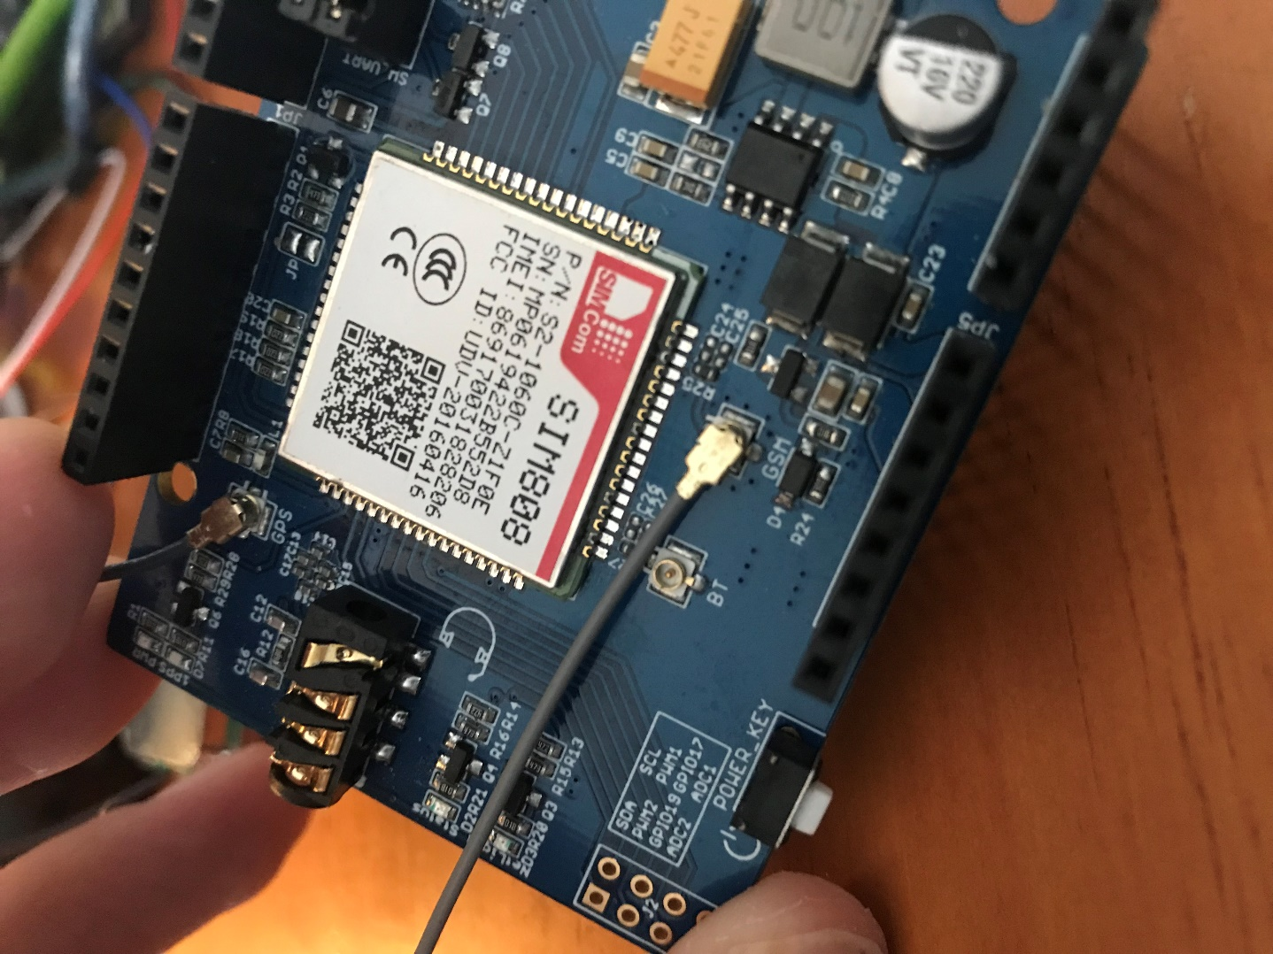

1. **Connect the USB Cable from the Arduino to your Computer**
2. **Place the GPRS/GSM/GPS Module into the Arduino MEGA as shown below.**

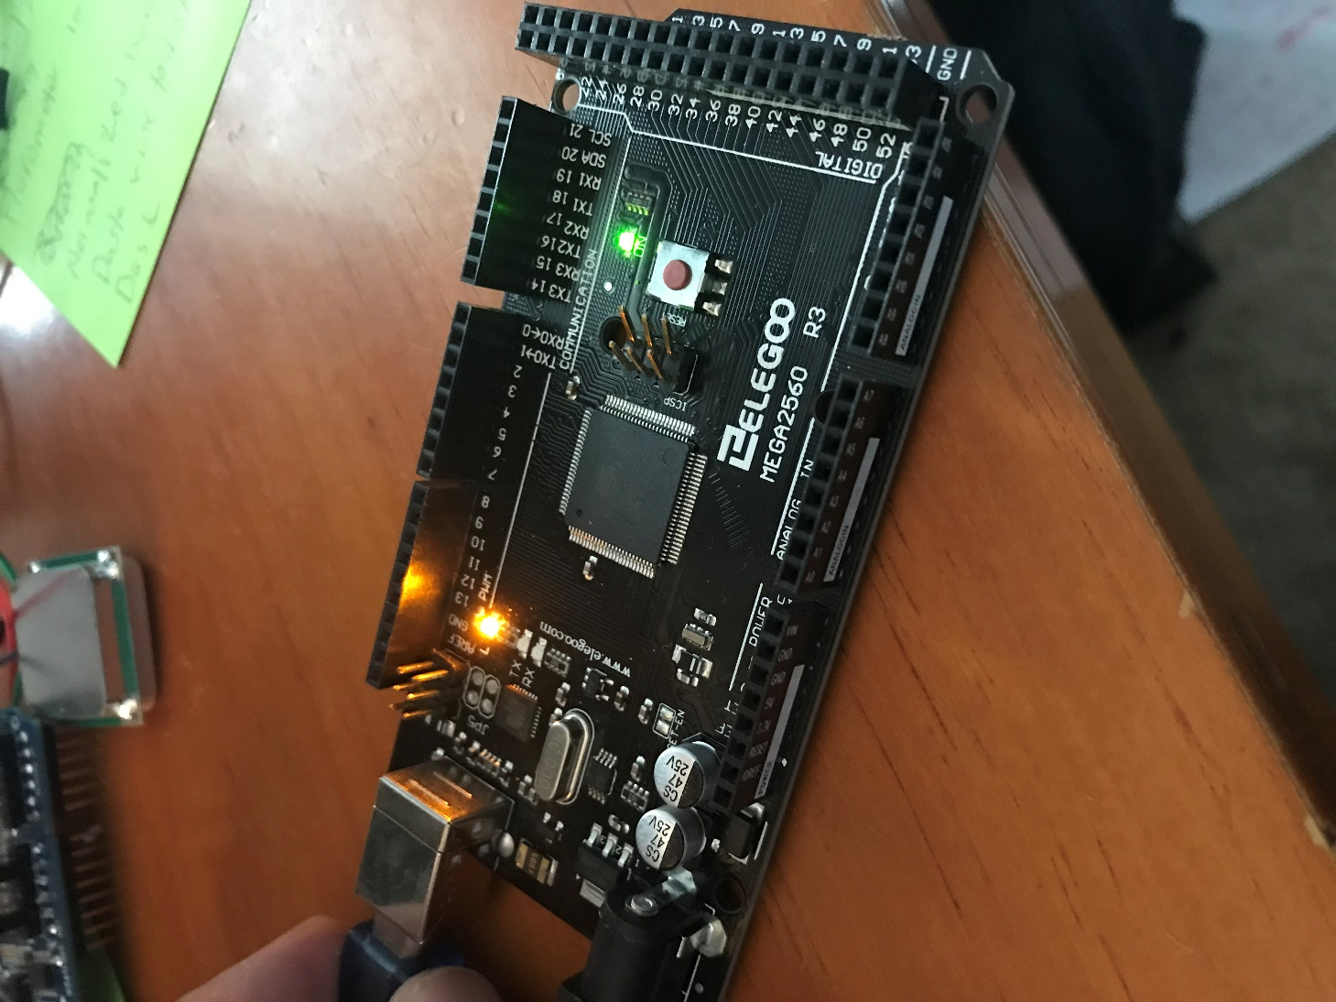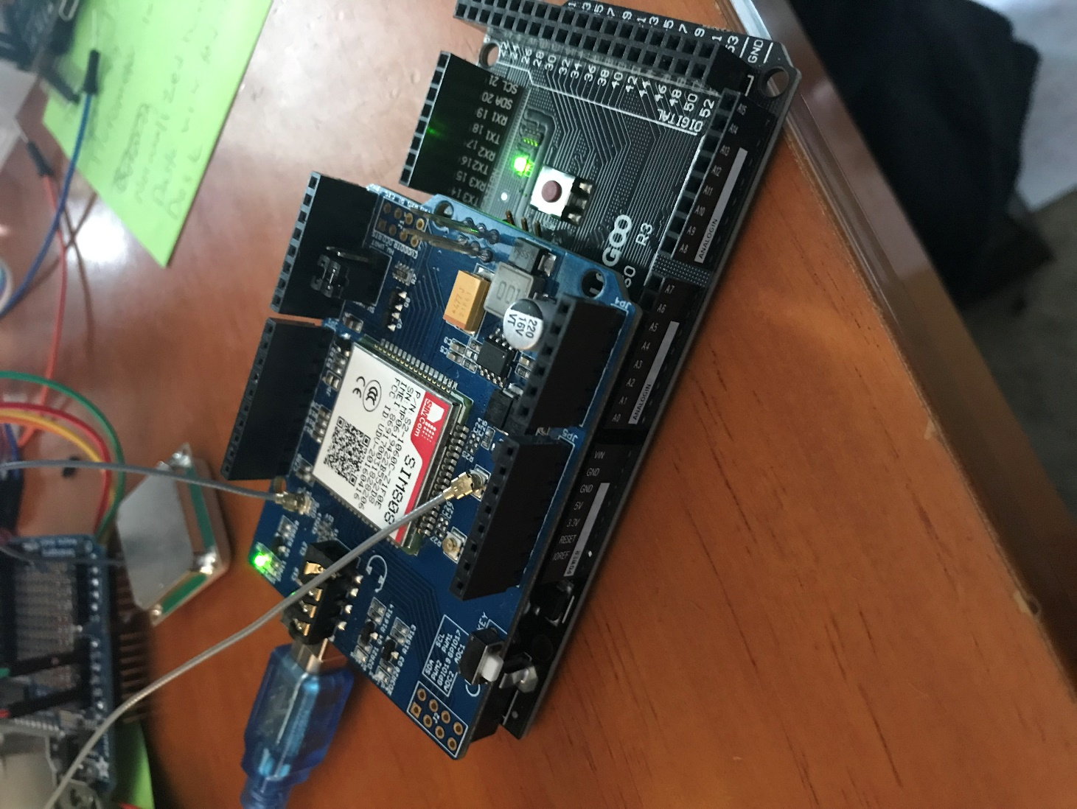

1. **Find a clear area to work with the soldering iron. Plug in and turn on the soldering iron (800 – 890 degrees F was used for this example).**
2. **Data Logging Shield Soldering**
   1. Find the data logging shield.
   2. Find the header pins that came with the data logging shield.
   3. Place the header pins into the GPRS/GSM/GPS shield as shown.

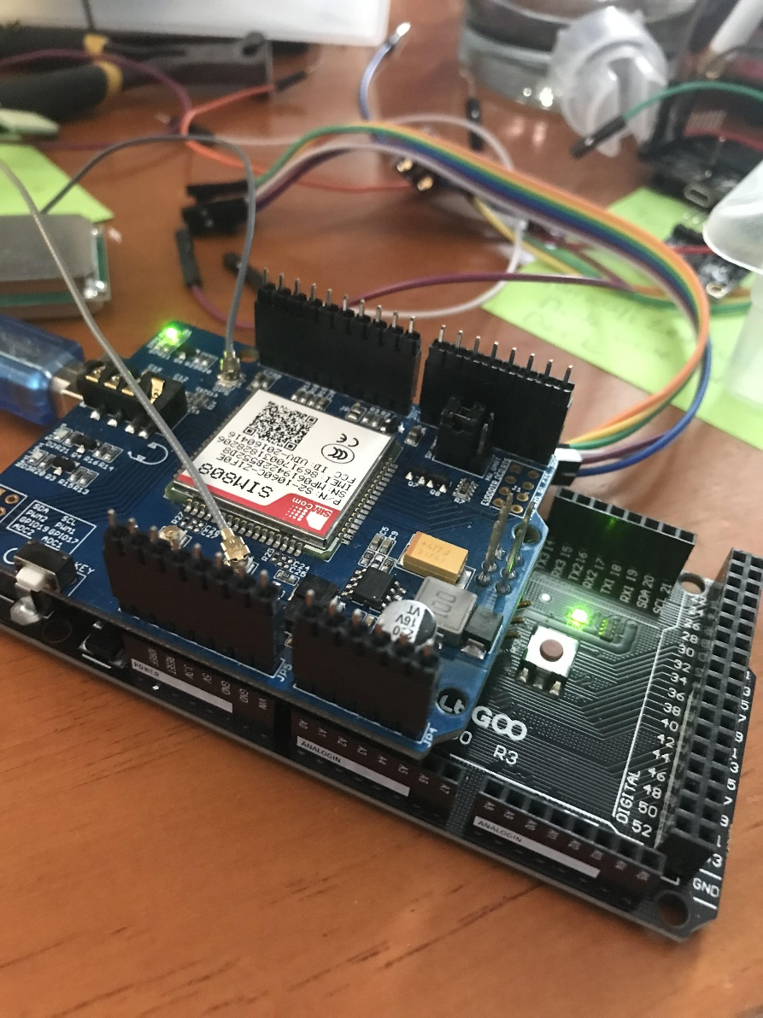

* 1. Place the data logger shield on top of the headers in the orientation shown below. Solder the outer pins to the data logger from the top. We will solder the inner pins sticking up in a minute.
  2. You will also note the six pins on the bottom right half of the screen. Those are SPI pins and should connect to the GPRS shield below using female headers facing downwards. What is shown is a makeshift solution specific to this board due to hardware changes. The Arduino communicates with the data logger shield with these pins and the sketch will not initialize if they are not connected. Solder 6 female headers facing down towards the GPRS board to the data logger board.

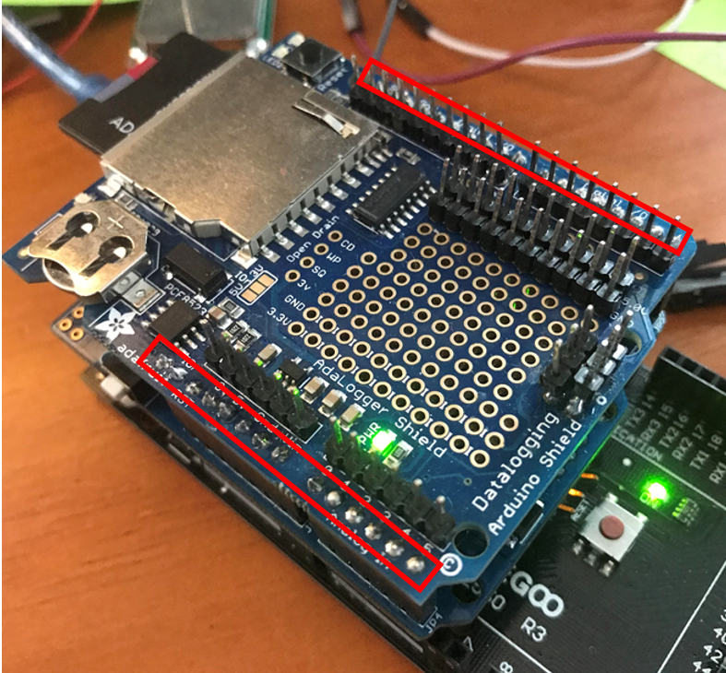

* 1. Remove the data logger shield once you have finished soldering the outer pins. Place header pins in the inner holes as shown facing with the long side upwards. These pins will give us additional connections for our sensors. Carefully, using a book or another flat object, flip the data logger shield over so that it is sitting on top of the unsoldered inner header pins. Solder these to the board from the bottom. Replace the board back on top of the GPRS shield as pictured below. It is not critical that these pins are exactly straight because nothing will sit on top of the data logger shield.

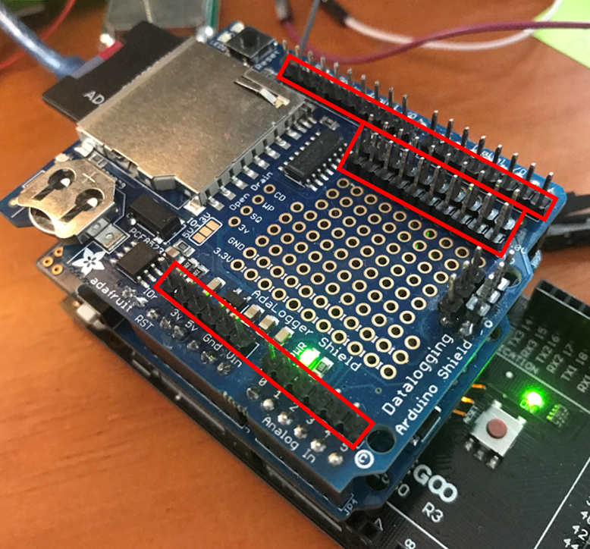

1. **Insert the CR1220 coin Cell Battery into the Real Time Clock (RTC). This battery allows the RTC to run even when there is no power supplied by the Arduino.**

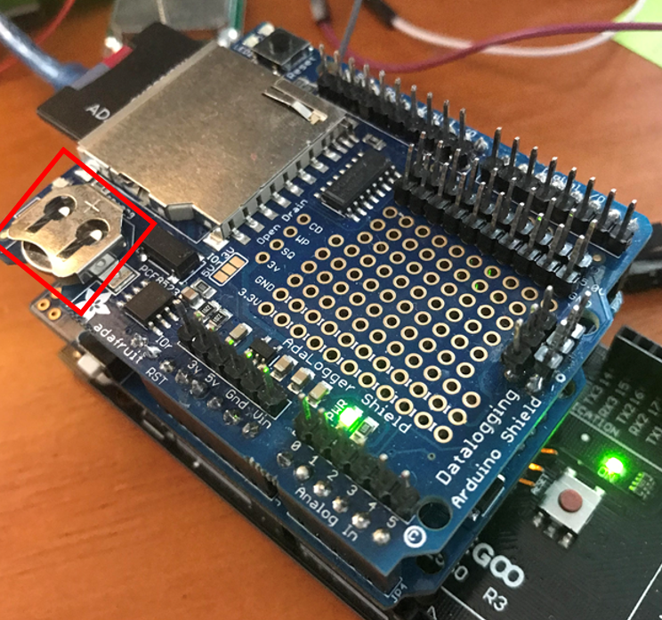

1. **Using two male-female jumper cables, connect TX1 18 on the MEGA to pin 8 on the data logging shield. Connect pin RX1 19 to pin 7 on the data logging shield as shown. This solves the MEGA/GPRS Board serial communication incompatibility.**

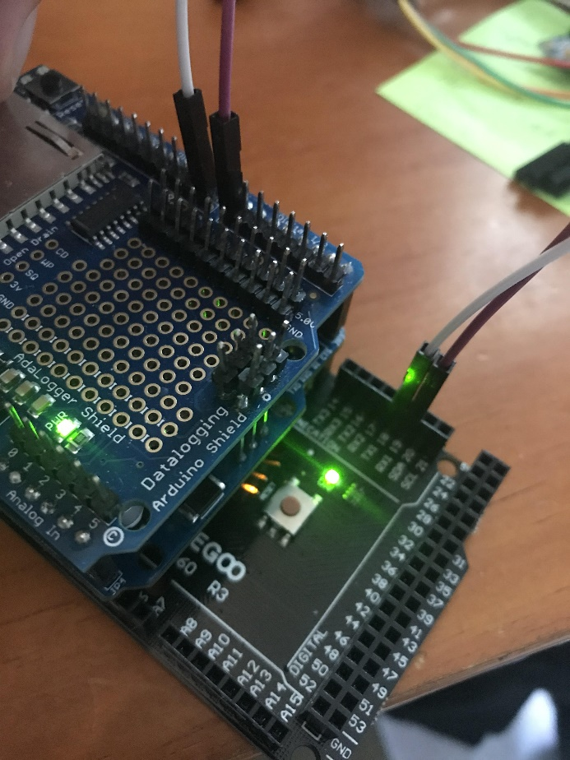

**Power System Setup**

First, we will solder a connector that we will use to connect the solar charger to the 5 Volt boost converter, as explained below:

1. **Find 2 Female Jumper Wires (red/orange and black preferably). Cut them down so they are approximately 2 inches long as shown.**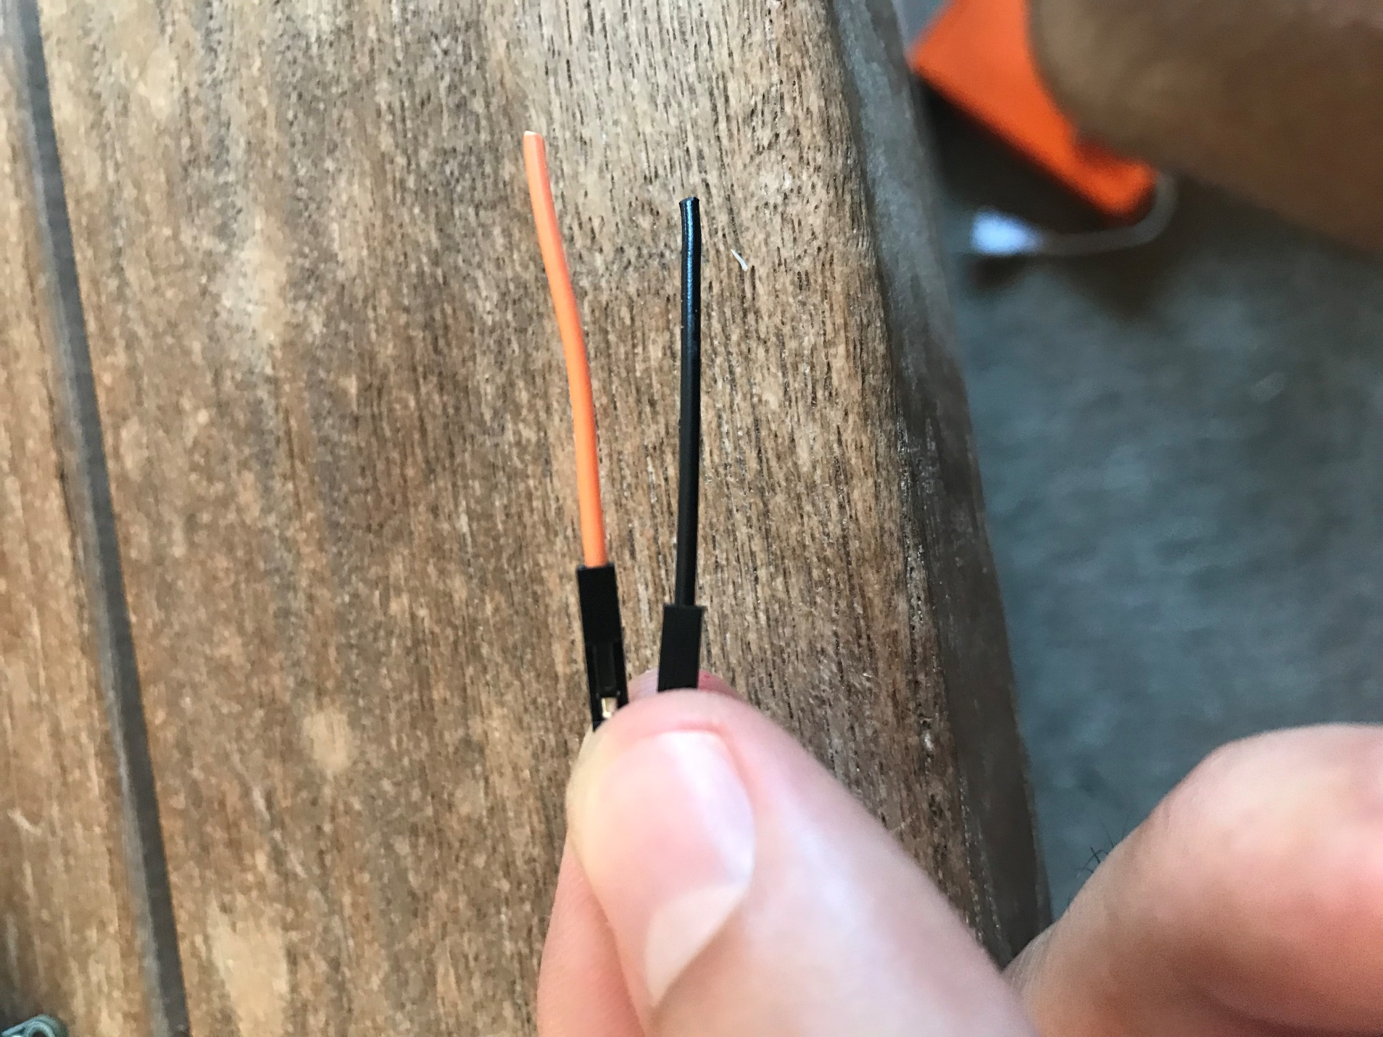
2. **Strip the ends of each with the wire strippers.**
3. **Find a JST connector and cut it so the wires are approximately 1 inch long as shown.**

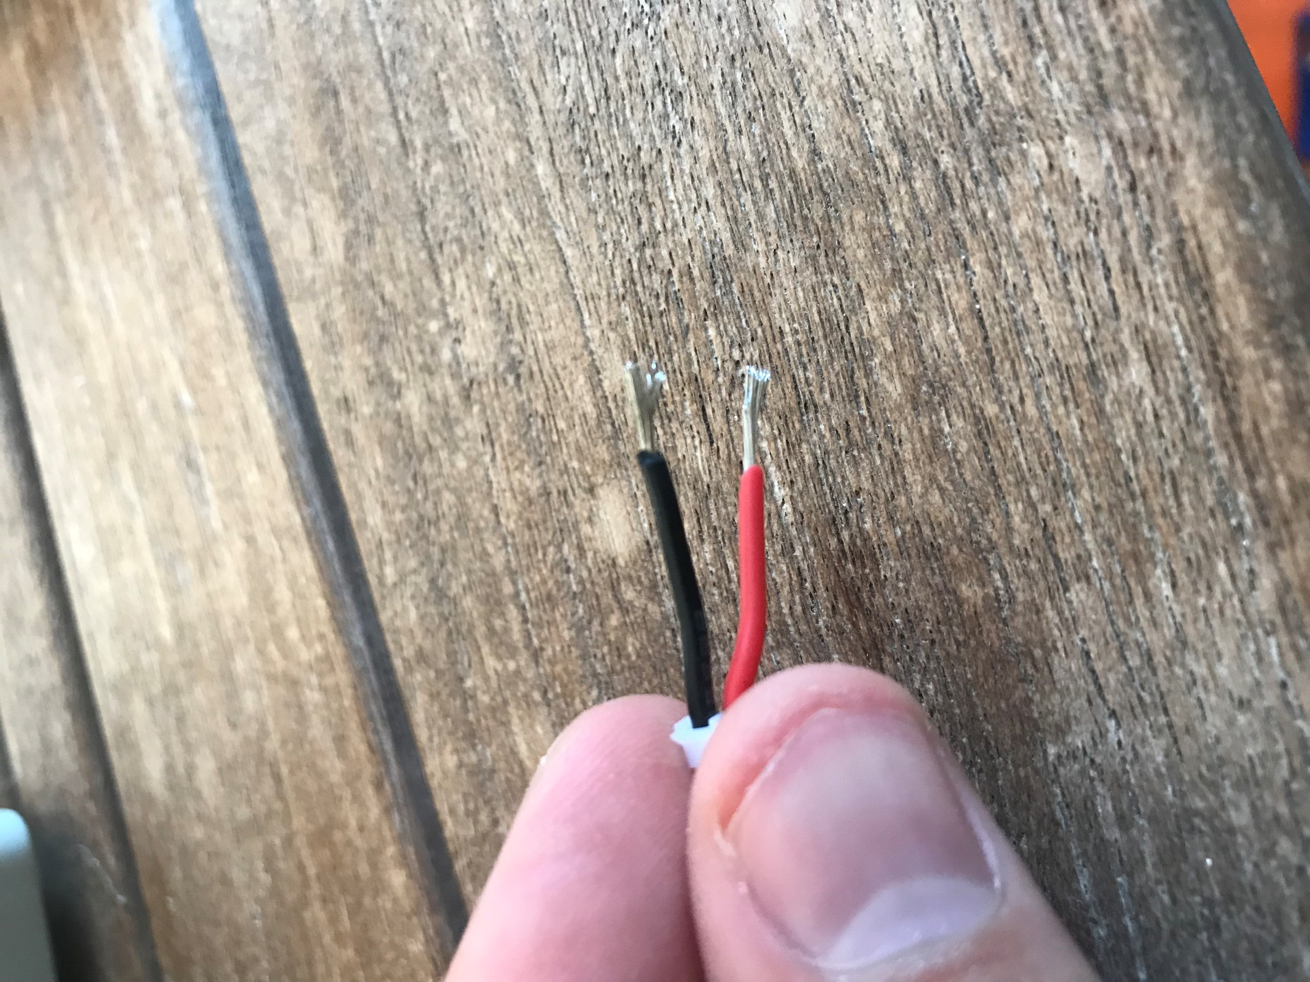

1. **Twist the orange (or red) jumper wire around the BLACK JST connector side. Some JST connectors have the black on the wrong side (black is on the wrong side in this example, i.e. it actually is the positive side, not GND). Make sure that the orange (or red) jumper wire is on the left side of the notch sticking up.**

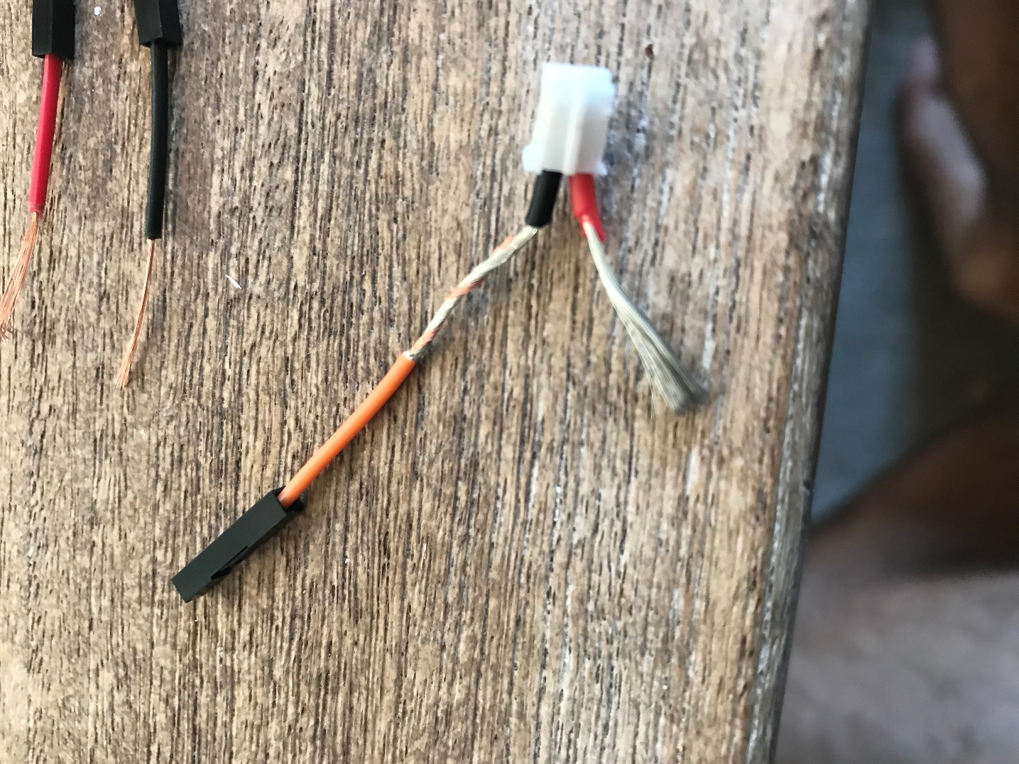

1. **Solder the orange wire to the left (black in this case) and the black wire to the right (red). Maybe your JST connectors will have the colors on the correct side.**

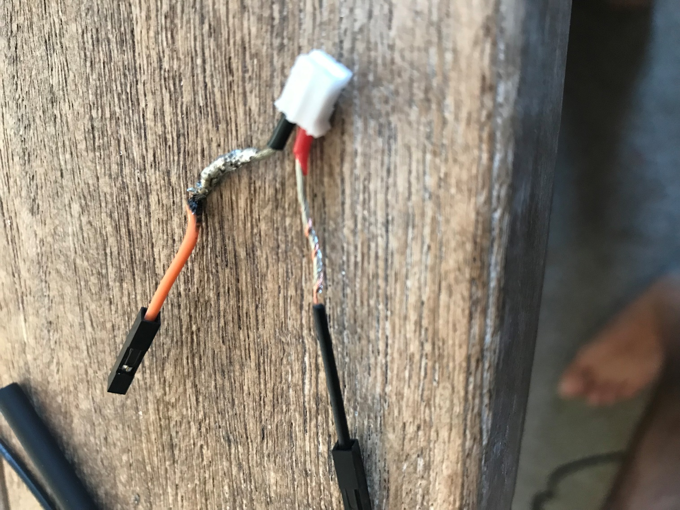

1. **Slide heat shrink over the jumper wires and use a lighter to shrink the tubing onto the wires as shown.**
2. **Find the solar charger. Attach the JST connector to the solar charger as shown.**

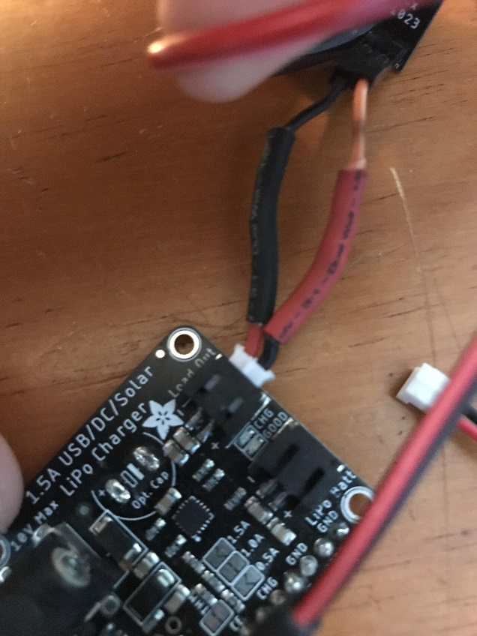

1. **Solder 3 header pins onto the 5V boost converter as shown in Step 17. The pins should be soldered to Vin, GND and 5V.**
2. **Find the 5V boost converter. Attach the two jumper wires to Vin and GND as shown (red/orange goes to Vin, black goes to GND).**

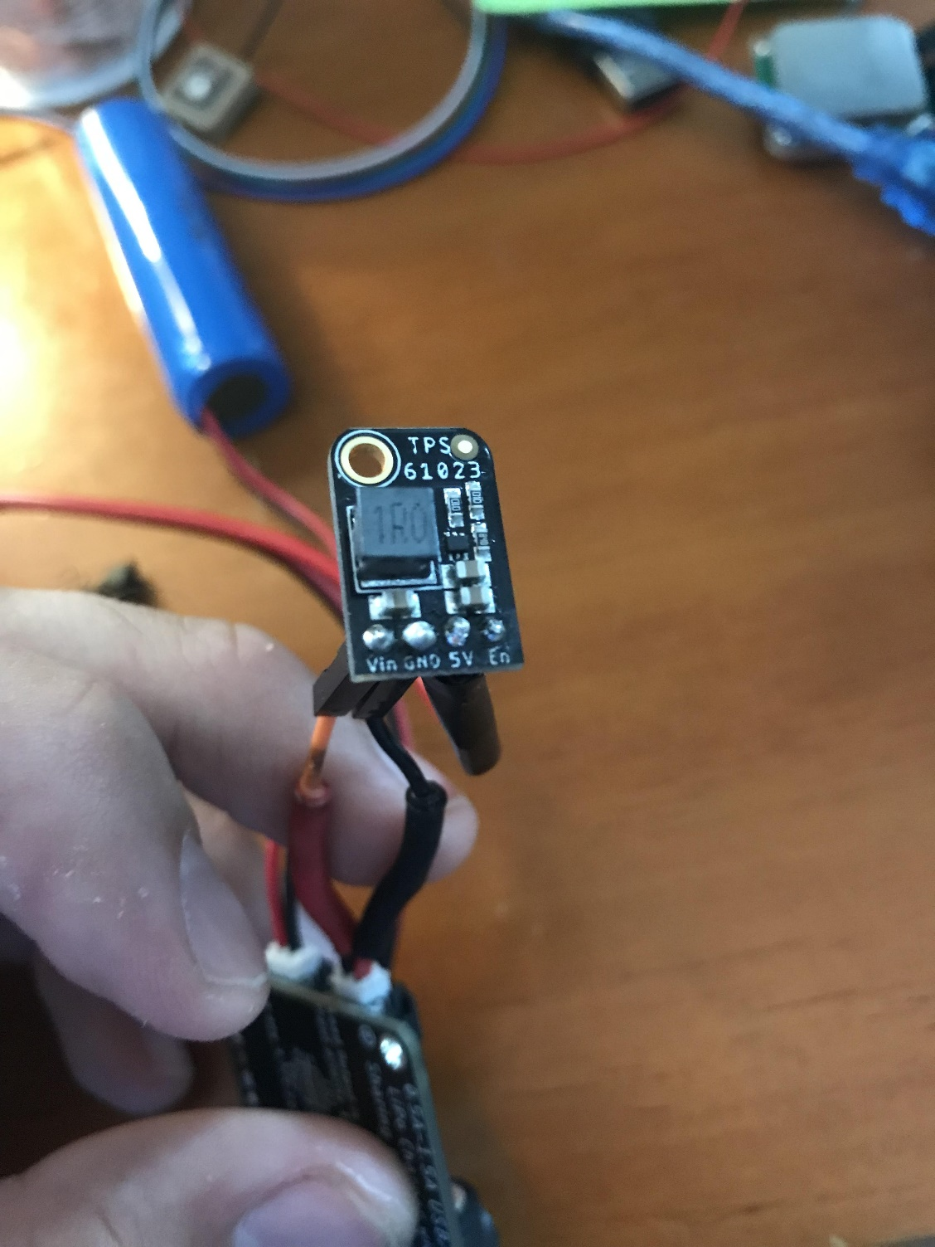

1. **Find a barrel connector and cut it so it is approximately 8 inches long.**
2. **Split the barrel connector wires down the middle and strip both ends if not stripped already.**
3. **Slide red heat shrink tubing up the red wire and black heat shrink tubing up the black wire.**
4. **Solder a single male header pin to the GND through hole on the solar charger so that the long part of the pin is sticking up.**

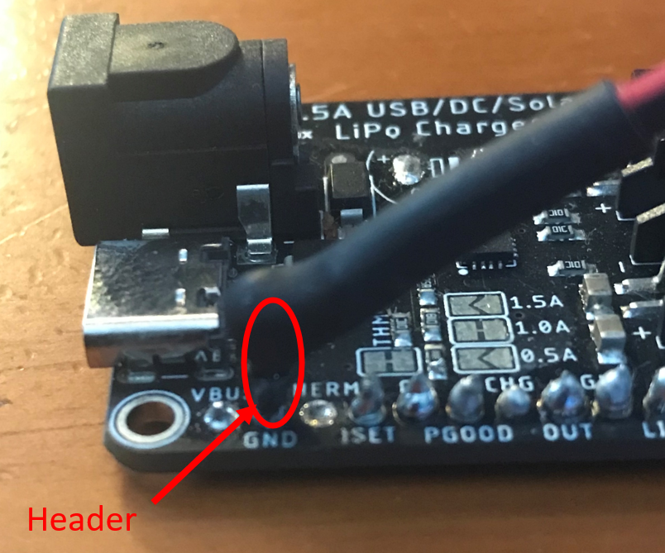

1. **Solder the black wire from the barrel connector directly to the GND pin on the solar charger as shown above. Slide the heat shrink over top of this and use the lighter to shrink it to form around the wires.**
2. **Solder the red wire from the barrel connector directly to the 5V pin on the 5V boost converter (in the picture below it is the wire on the far left). Slide the heat shrink tubing over the exposed metal and use a lighter to shrink the tube, being careful not to damage the boost converter with the flame (electrical tape was used in the example shown).**

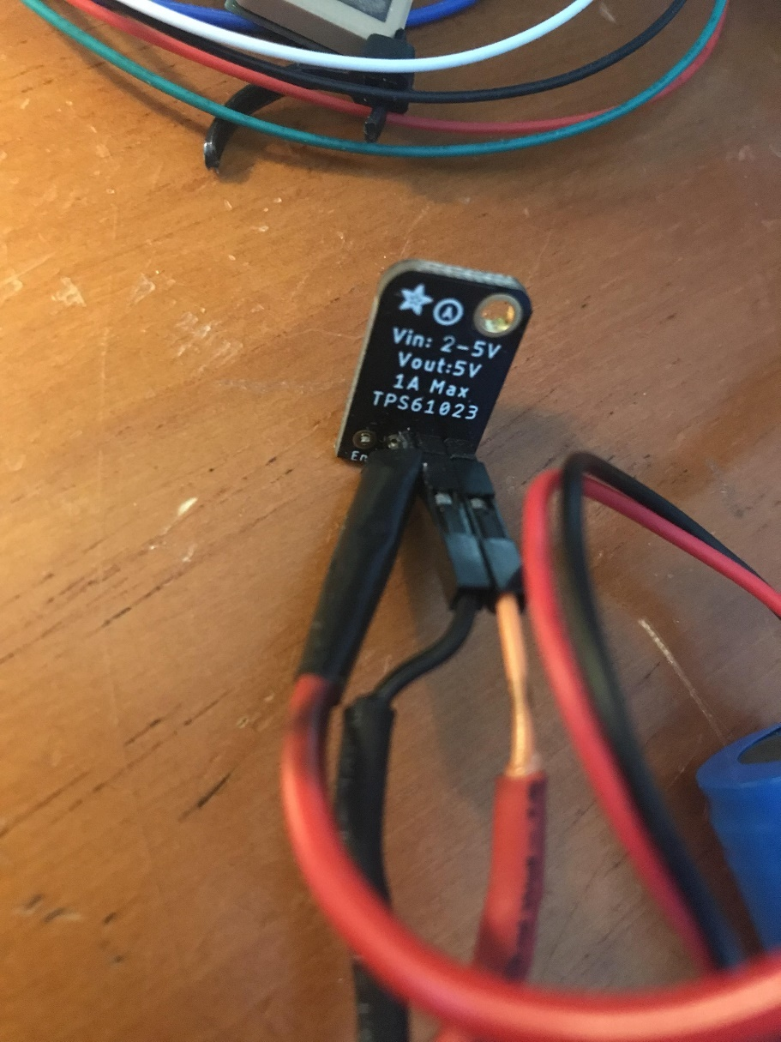

1. **Attach the 3.7V 2200 mAh battery JST connector to the solar charger where it says LiPo Batt.**

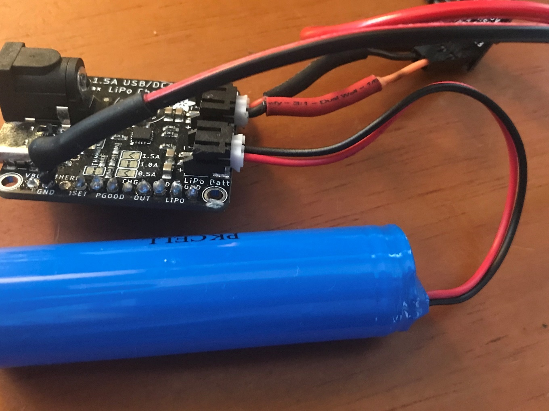

1. **We are now going to install the NPN transistor, which will allow the real time clock to cut power to the Arduino for long periods of time when no data is being sampled. About 2 inches from the barrel connector head, cut only the black barrel connector wire, strip both ends and twist them so they are easy to work with.**

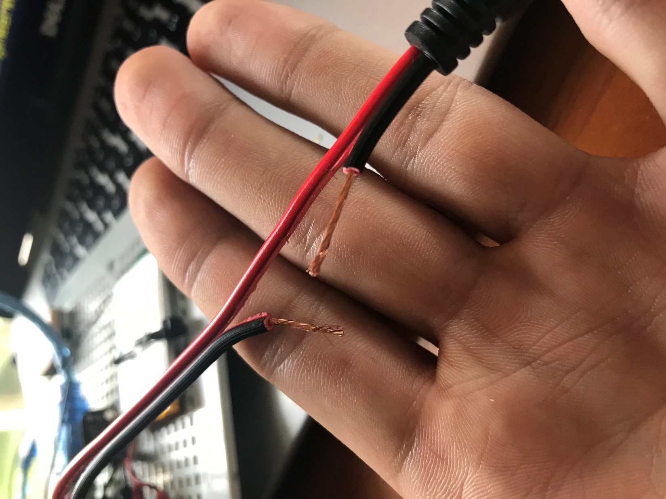

1. **Next, find the 2N2222 NPN transistor. A transistor is an electrical component that can switch and amplify electrical signals. It has 3 wires:**
   1. Emitter
   2. Base
   3. Collector

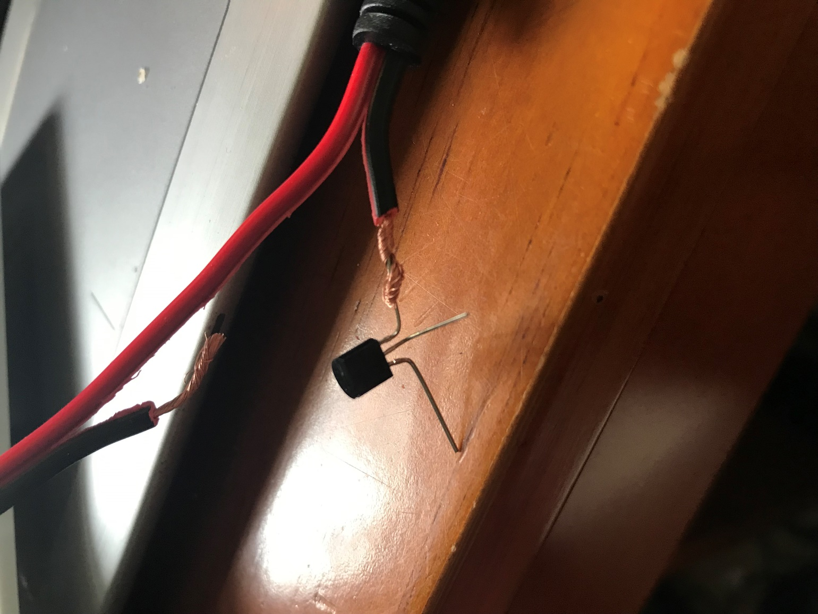

1. **Hold the transistor so that it is facing with the flat side towards you. Twist the black barrel connector wire around the collector on the right. Solder these together.**
2. **Repeat the process with the emitter on the left, soldering it to the black wire that will go to the solar charger. Bend the base in the middle out at 90 degrees so that it is not touching the other wires.**

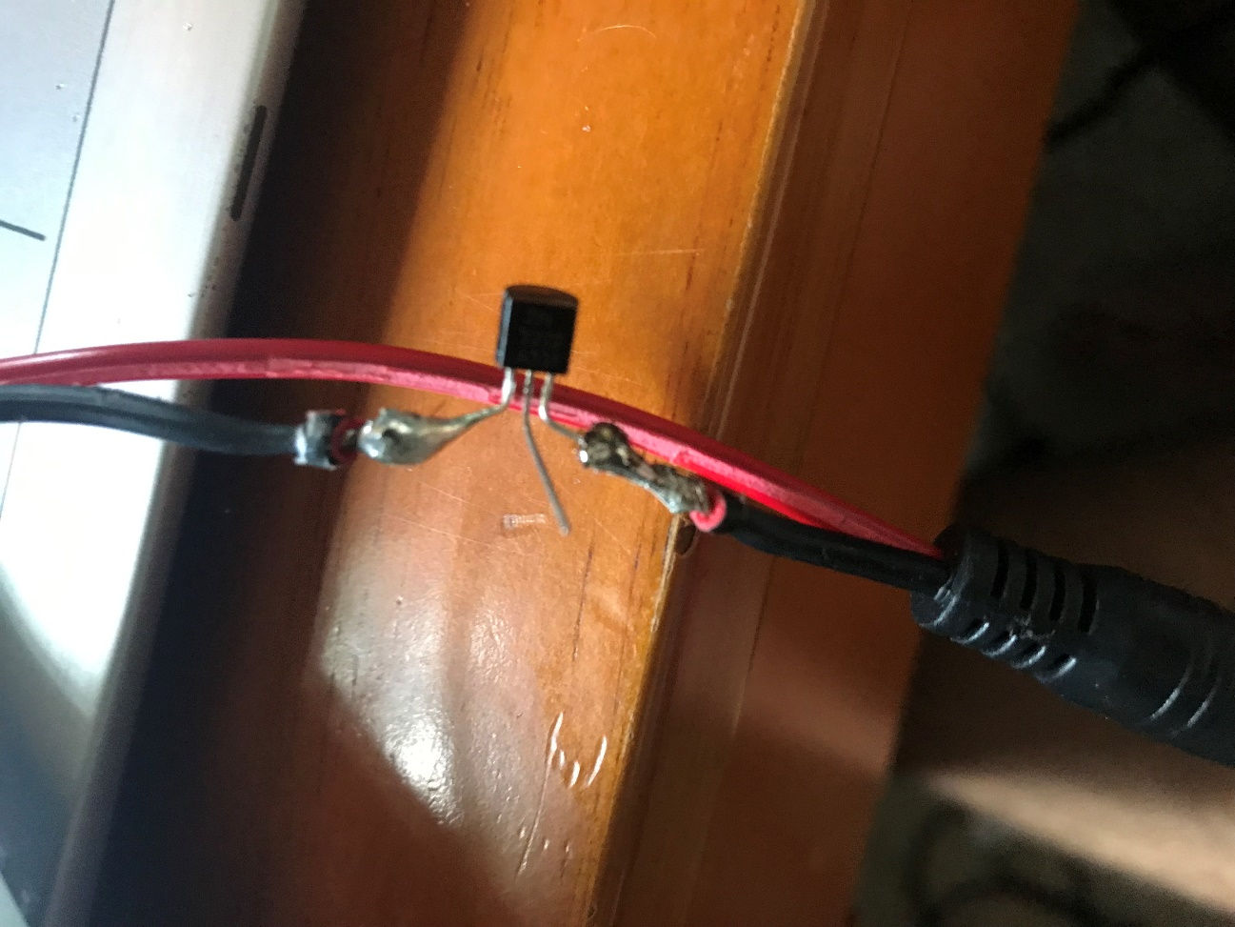

1. **Using electrical tape, wrap the exposed solder on the emitter and collector sides so there is no chance of them coming into contact with each other or with the base in the middle.**

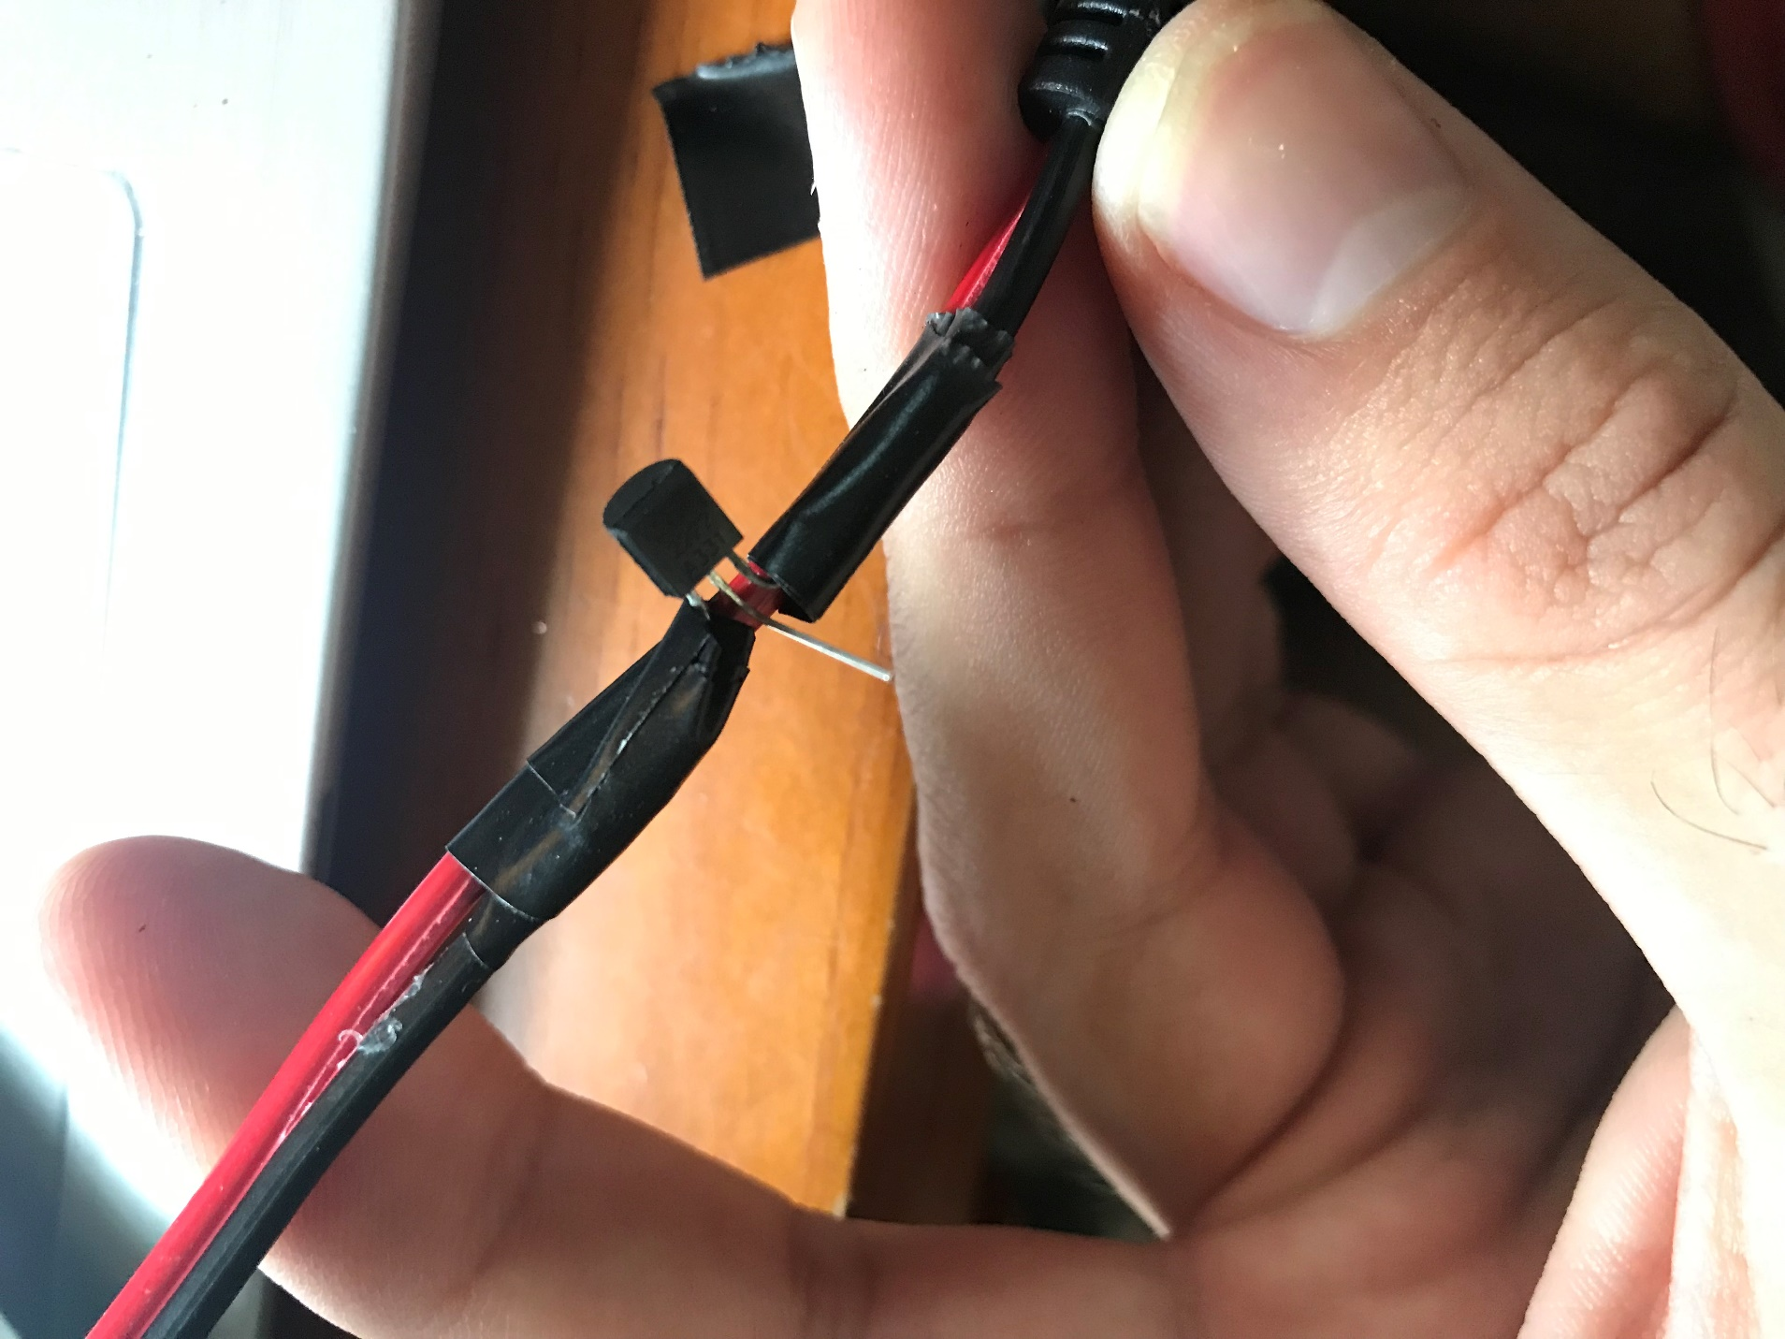

1. **Find a jumper wire with at least one female end. Cut off the other end and strip the wire so that the metal is exposed. Wrap this around the center base and use solder to secure the connection. Wrap this with electrical tape or heat shrink. The female end will connect to the top of the data logger shield and will send the signal to cut power to the Arduino.**

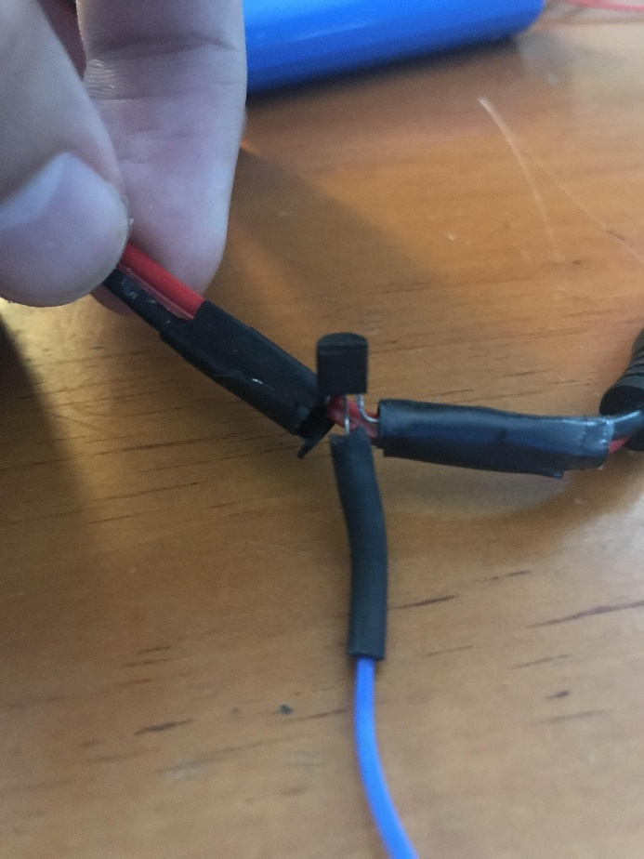

1. **Find the solar panel and buoy top. We are going to solder another connector on. Cut the existing solar panel power connector so that it is approximately 8 – 10 inches long so as to remove the existing connector type. The connector type that it uses is not what we need.**
2. **The difficult part – Strip the red, outer silicone-like tubing away from the two internal wires. The internal red and black wires should stick out about an inch from the outer red tubing. It may be useful to use an exacto knife and/or the wire strippers. If you mess up, you can cut a little farther down towards the solar panel and try again. The silicone is pretty tough and the copper wire is too easy to accidentally cut when we want it intact.**
3. **Once you have done that, strip the inner wires and solder them to a barrel connector using heat-shrink tubing as shown below.**

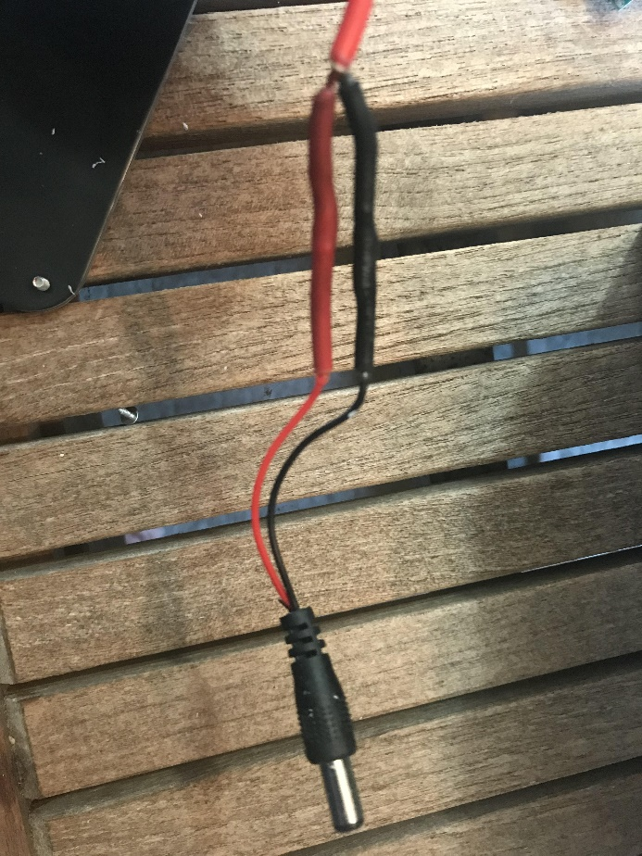

**Sensor Setup**

**BME280 Temperature, Pressure and Humidity Sensor**

1. **Find the BME280 sensor. Solder the header pins provided as shown below.**

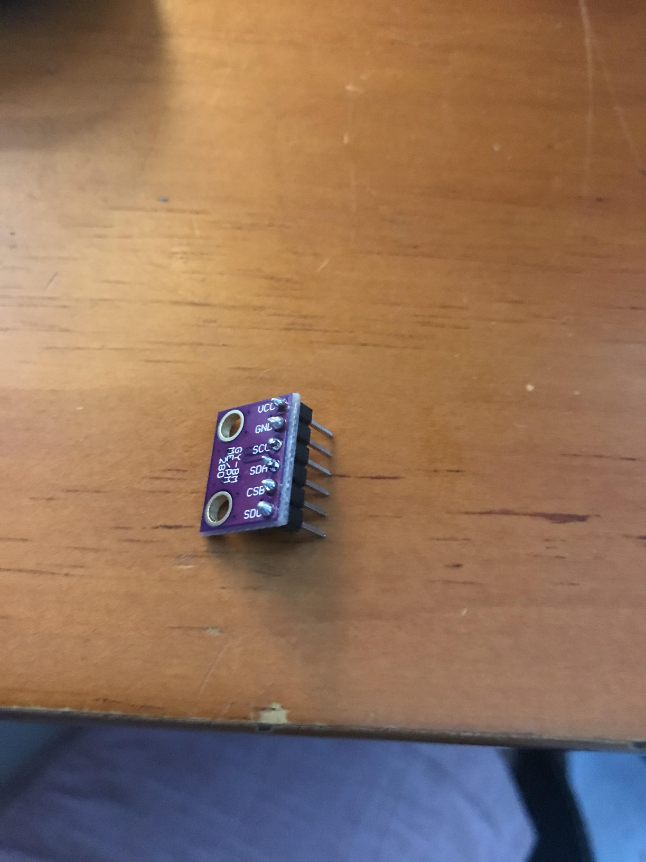

1. **Attach 4 female-female jumper wires from VCC, GND, SCL and SDA on the BME280 to the data logger shield as shown below for the I2C communication interface.**

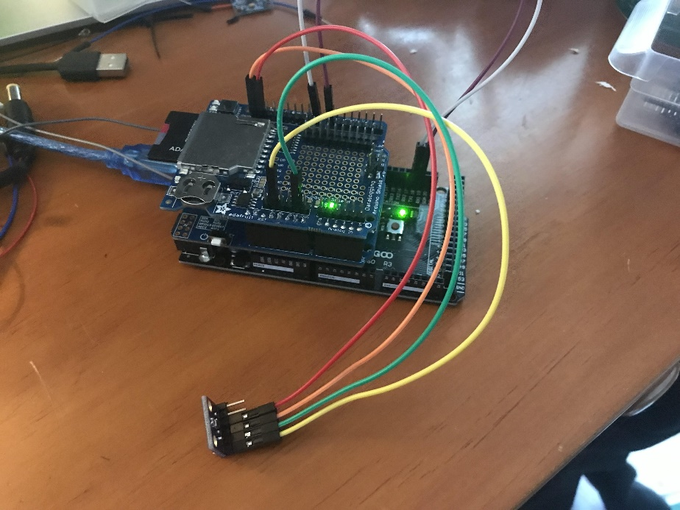

1. **You are now ready to upload the code and test in the desktop configuration.**

**Desktop Test Software Configuration**

1. **Download the Arduino Integrated Development Environment (IDE)** [**here**](https://www.arduino.cc/en/software)**. Select your platform from the right half of the page.**

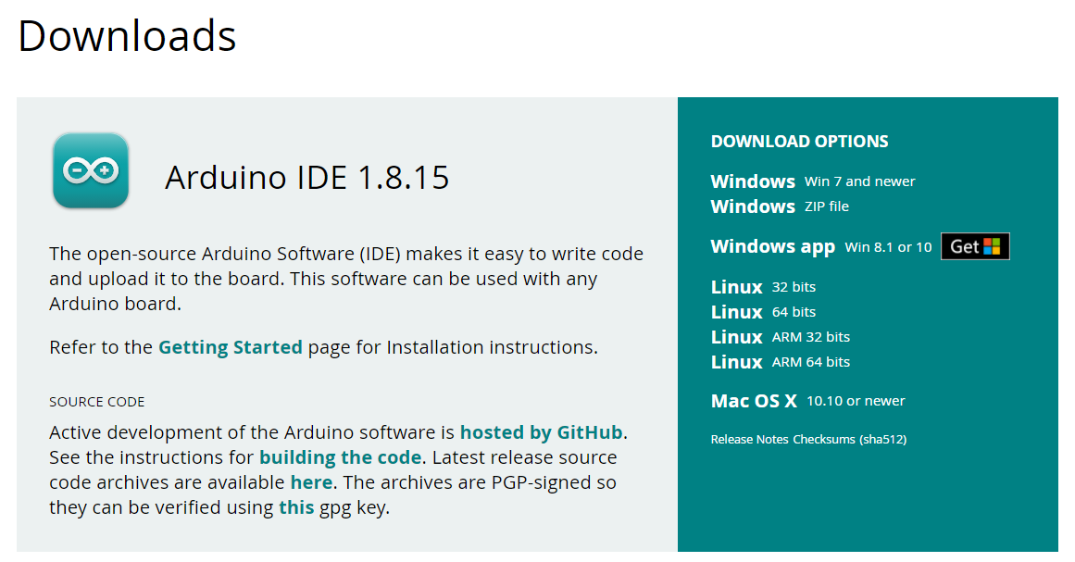

1. **Download project code**
   1. Go to <https://github.com/oyetkin/iotbuoy>
   2. Click code -> download zip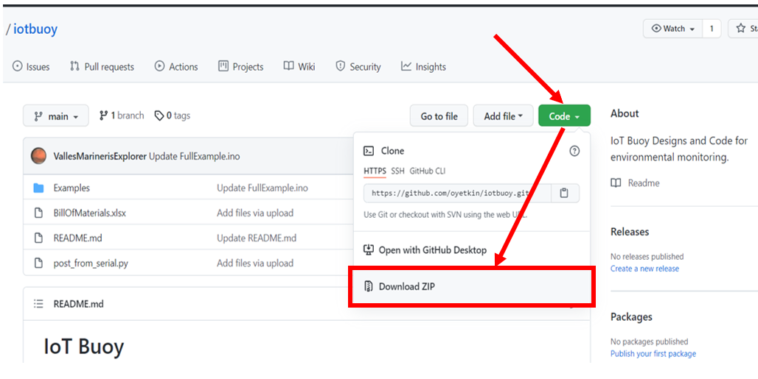
   3. Unzip the folder to your chosen project folder (can be anywhere on your computer)
2. **Install required libraries for this project**
   1. In the IDE, go to Tools -> Manage Libraries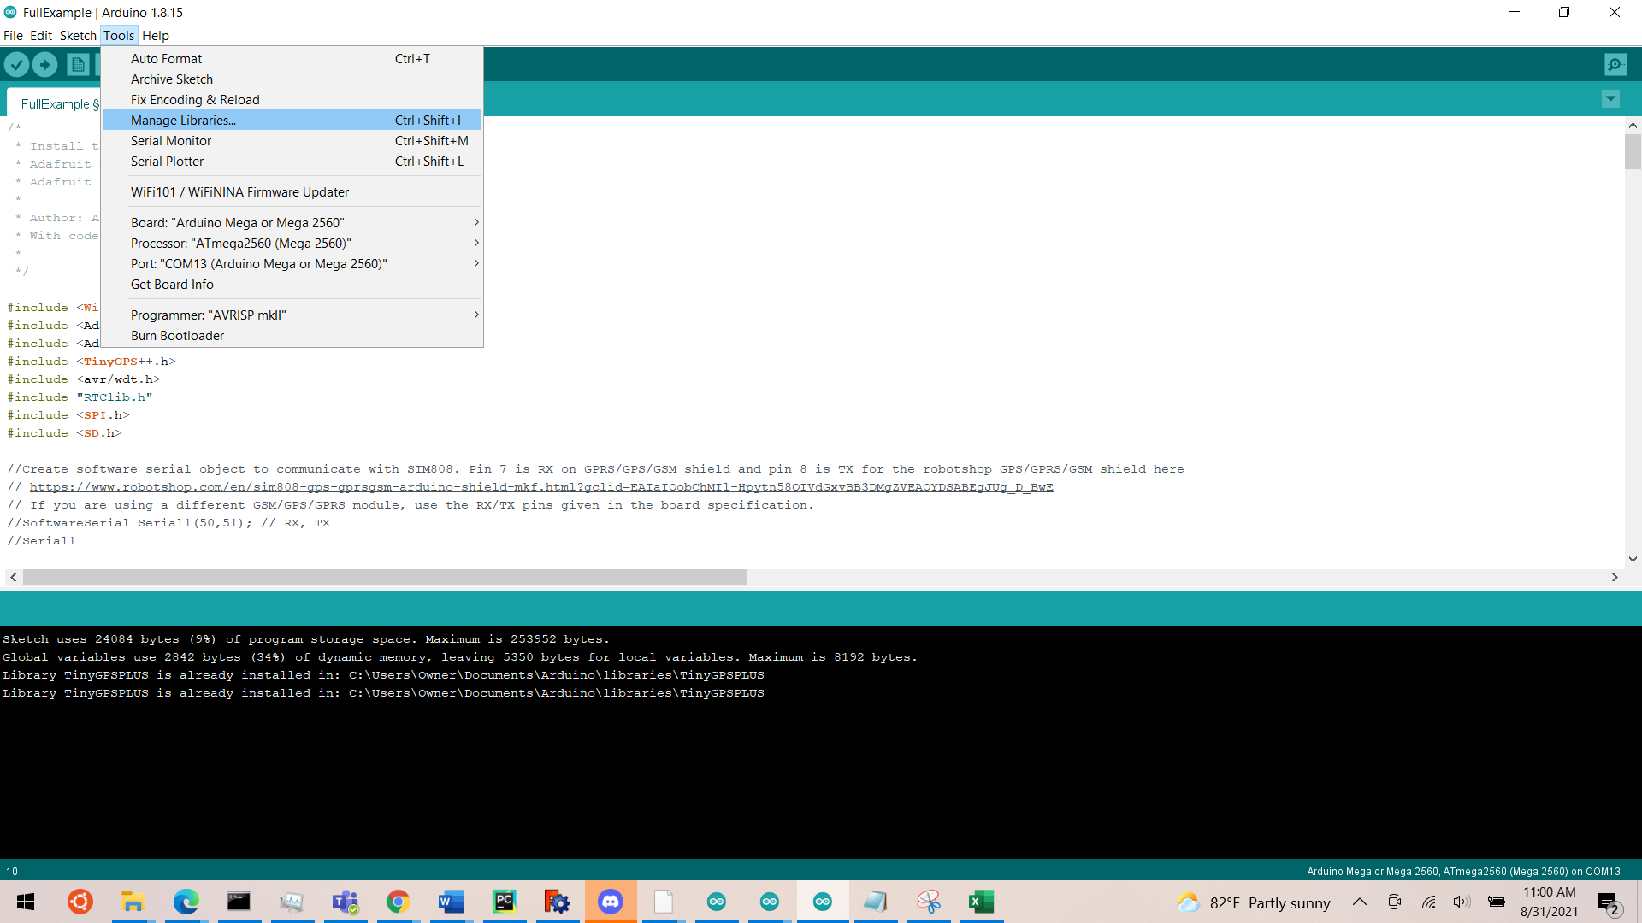
   2. Type in these exact phrases in the library manager and install them
      1. Adafruit Unified Sensor
      2. RTClib
      3. Adafruit BME280 Library
      4. TinyGPSPLUS
3. **Increase the Serial Buffer Size From 64 bytes to 256 bytes**
   1. Go to C:\Program Files (x86)\Arduino\hardware\arduino\avr\cores\arduino
   2. Open HardwareSerial.h
   3. In HardwareSerial.h, replace:

**#if !defined(SERIAL_TX_BUFFER_SIZE)**

**#if ((RAMEND - RAMSTART) < 1023)**

**#define SERIAL_TX_BUFFER_SIZE 16**

**#else**

**#define SERIAL_TX_BUFFER_SIZE 256**

**#endif**

**#endif**

**#if !defined(SERIAL_RX_BUFFER_SIZE)**

**#if ((RAMEND - RAMSTART) < 1023)**

**#define SERIAL_RX_BUFFER_SIZE 16**

**#else**

**#define SERIAL_RX_BUFFER_SIZE 256**

**#endif**

**#endif**

With:

**#define SERIAL_TX_BUFFER_SIZE 256**

**#define SERIAL_RX_BUFFER_SIZE 256**

You may have to save HardwareSerial.h to a separate location first and then copy and paste it into the same folder due to administrator privileges of Program Files.

1. **Set your sensor name. Find the line of code that says**
   1. String device_name = "IoT_Station_1"; // Name your station
   2. Change this to whatever you would like to call this buoy.
2. **Set your Access Point Name (APN). For this example, a Things Mobile IoT SIM Card was used. The APN for Things Mobile is “TM”, which is set on line 126 in the FullExample sketch:**
   1. Serial1.println("AT+SAPBR=3,1,APN,TM"); // Change "TM" to the APN provided by your carrier
3. **Ensure the GPRS Shield is powered on by checking the LED status. If it is on, the center LED will be steady and the right LED will flash periodically, as shown below.**

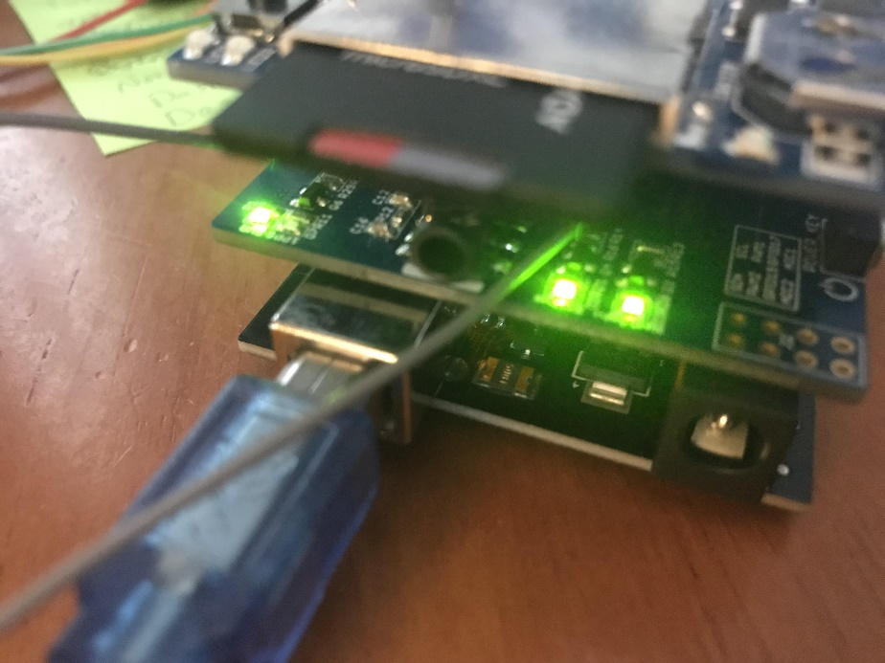

1. **If only the left most light is on, turn the GPRS board on by pressing the white power button for a few seconds until the other lights turn on (the power button is on the right side of the board as shown in the above image).**
2. **Set the correct board type (Arduino MEGA 2560).**

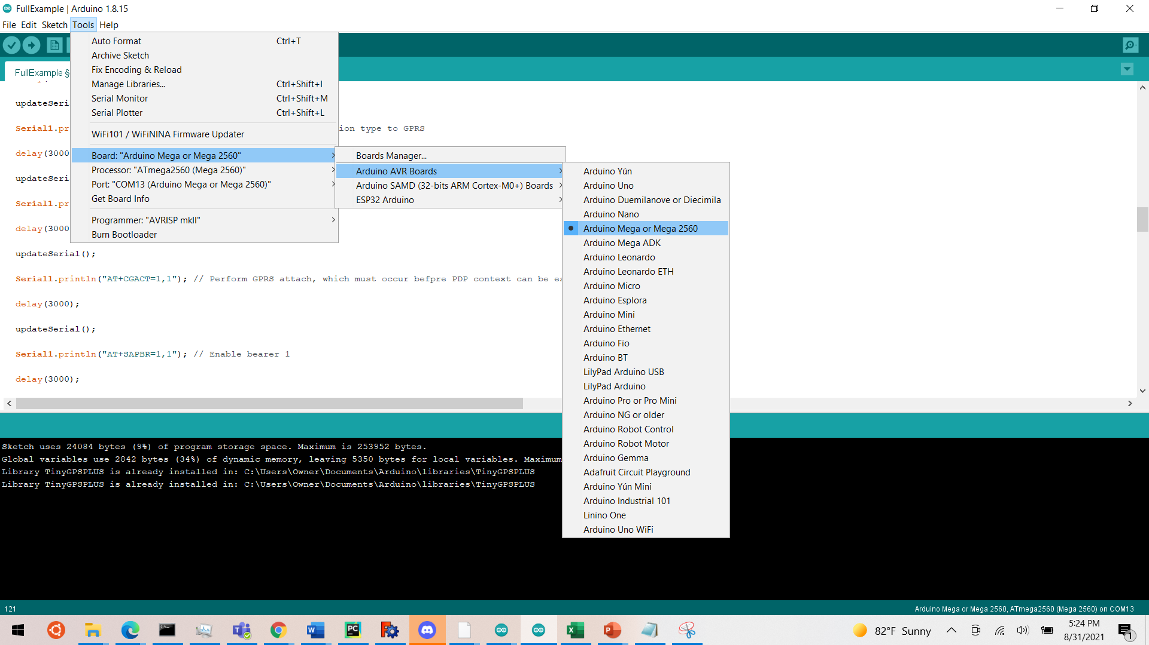

1. **Set the correct COM port. This may be different for you, just select the one that says Arduino MEGA.**

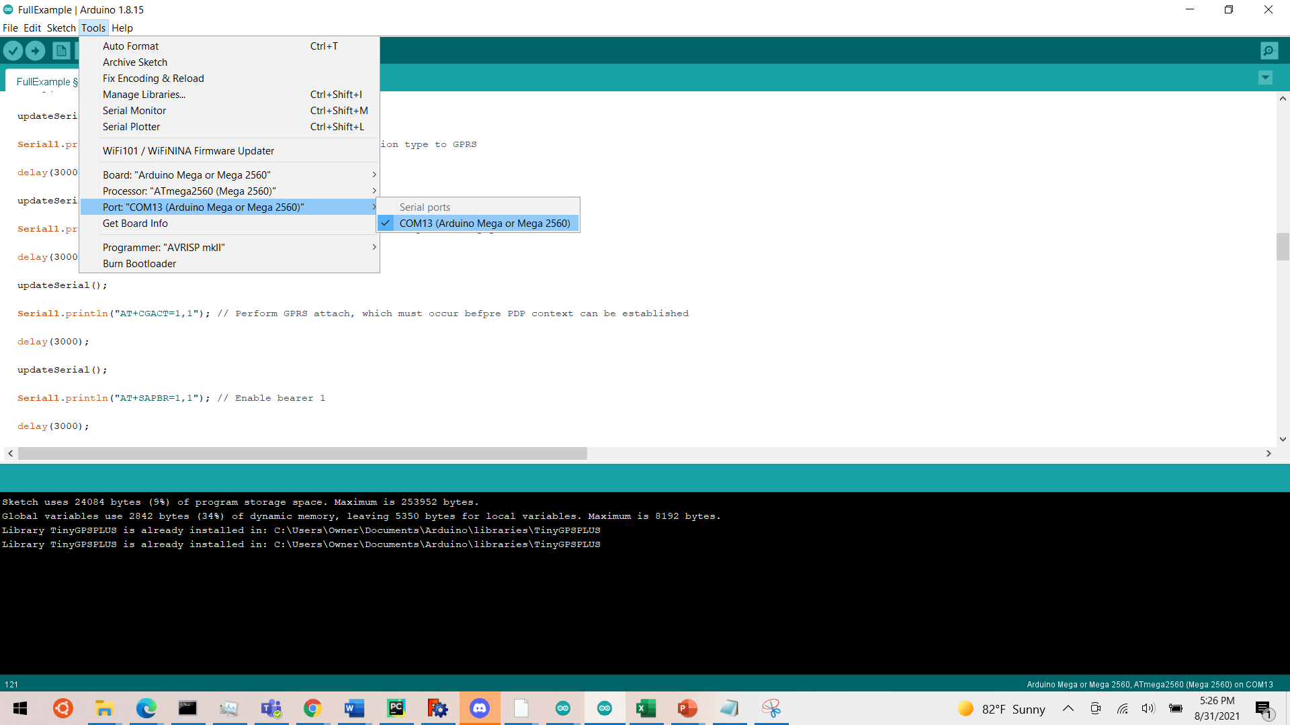

1. **Compile and upload the code. If the code does not upload within 30 seconds, or if you get an error relating to avrdude, unplug the USB connector, plug it back in and turn on the GPRS module.**
2. **Open the Serial Monitor**

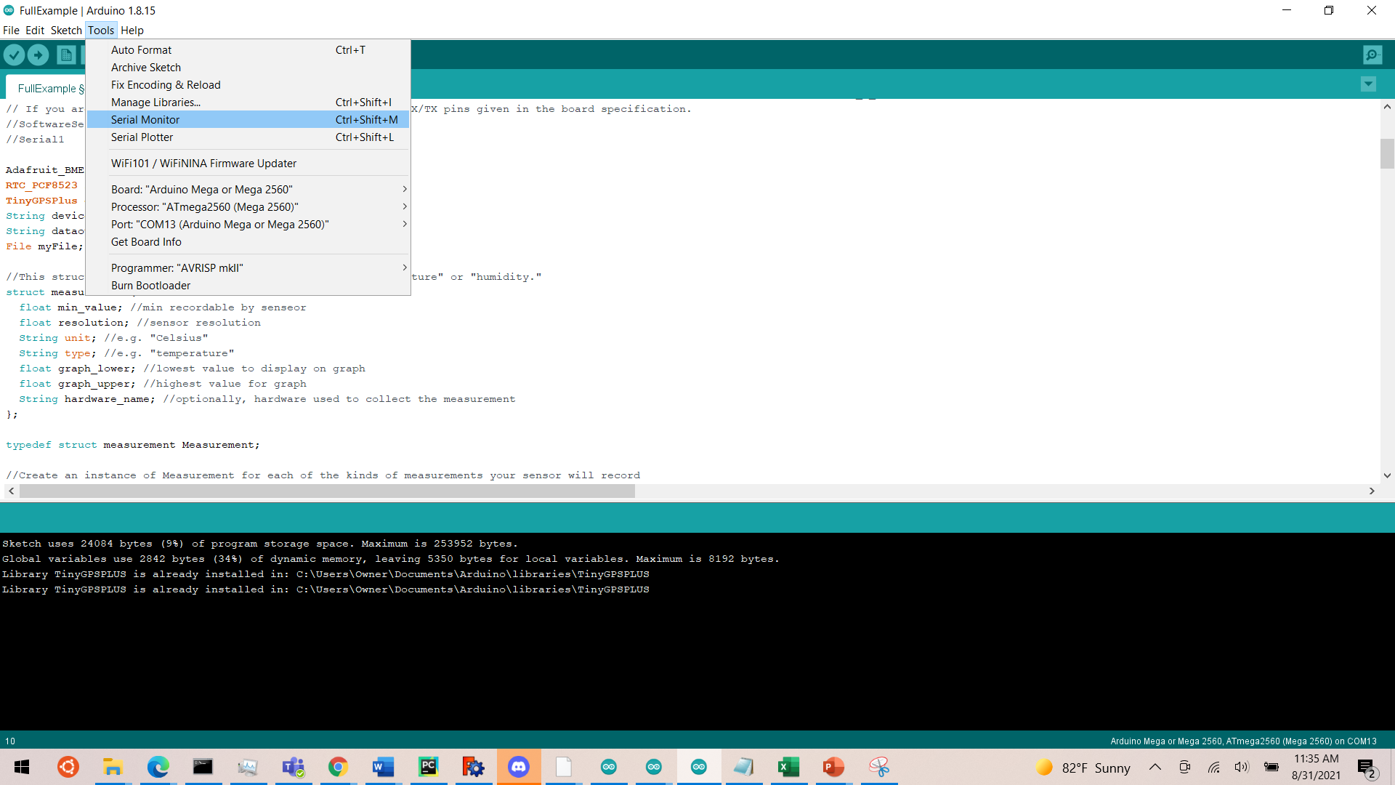

1. **In the bottom right, set baud rate at 57600. This is necessary for the GPS and RTC to work properly.**
2. **Monitor Status of Serial Monitor Commands. The output should look something like this. If you receive 500, 21, 0 Internal Server Error, the data was actually sent correctly.**

**Viewing Results**

1. **Open a web browser and navigate to this address:** [52.26.55.255:8080/api/v0p1/sensor_by_id/IoT_Station_2](http://52.26.55.255:8080/api/v0p1/sensor_by_id/IoT_Station_2)

**Field Deploying**

1. **Sand or file down the buoy top and buoy base so that they fit together snugly as pictured.**
2. **In the FullExample.ino script, at the top, set int FieldDeploy = 1.**
3. **Compile and reupload the script.**
4. **Remove the USB connector from the computer and attach the solar charger wiring harness as shown, connecting the barrel connector to the Arduino MEGA.**

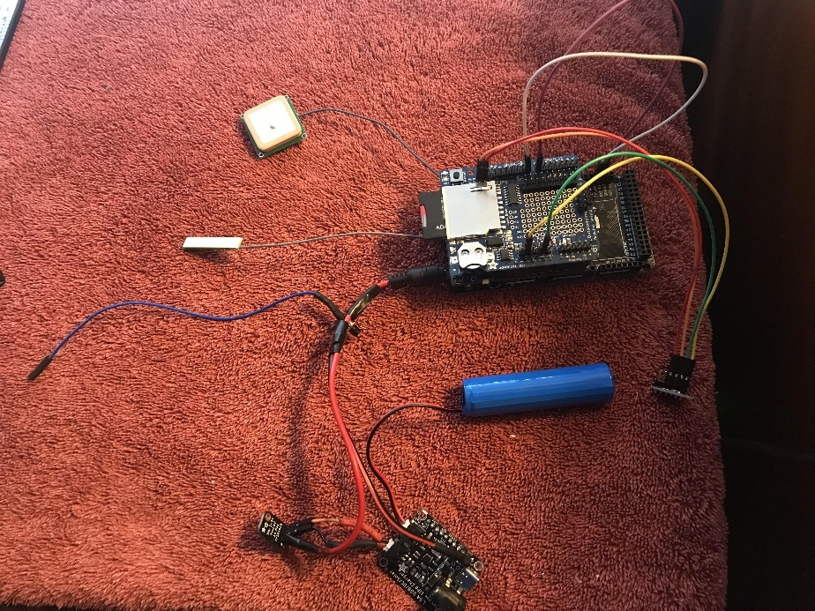

1. **Connect the blue wire from the NPN transistor to digital pin _____. This is used to turn off the Arduino.**
2. **Connect the solar panel barrel connector to the barrel plug on the solar charger as shown.**
3. **Use hot glue or DP100 epoxy**
4. **Place the 30 AWG wire around the circumference of the buoy seal as pictured.**

**Future Work**